**PMI BeLux Day 2014**

## **“Project Management, When Art Meets Science”**

**October 4th, 2014  
PXL Congress Centre: Hasselt, Belgium**

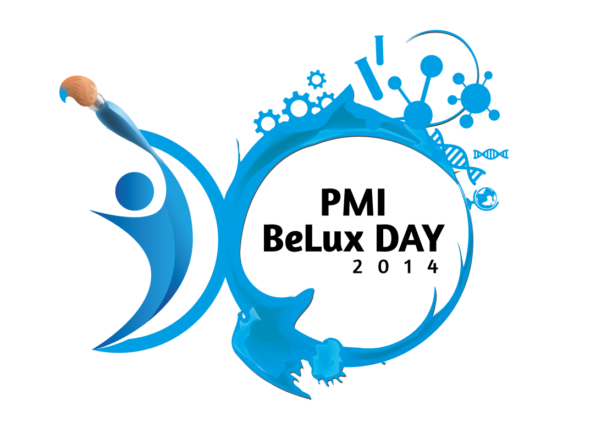

“Project Management, When Art Meets Science”:

Around this theme, several types of conference sessions will be held in parallel: master classes, best practices, hard & soft skill workshops.

**Book the date and Stay tuned for more information.**